CTM-I Use Case

Update CMTA Information

Version 0.1

Use Case Name | Update CTMA Information
Actor | Firm User, Market Ops, Ops, App Support
Pre-conditions /Assumptions | User has Browser and is aware of the http path to the application.  User has successfully logged into the CTM-I application.  User has the right role to see the menu options.
Post Conditions | None
Screenshot | 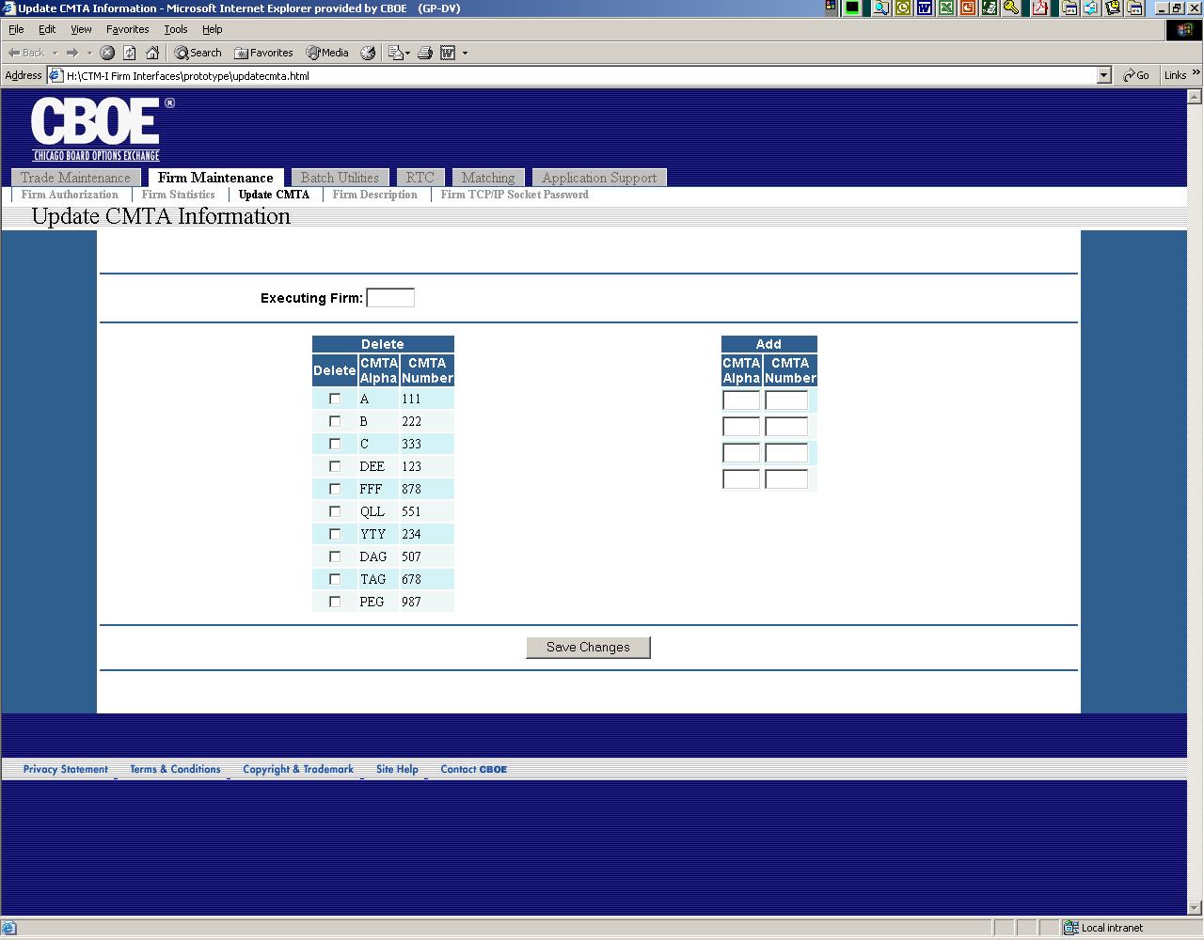
Flow of Events | - User selects “Update CTMA Information” from the menu.  - Update CTMA Information screen appears  - User can delete or add new firm Update CTMA Information data and save the changes by pressing the “save change” button (field details, paging, ctm-r)
Alternative Path | - If the system is down and the validation could not be performed than the system will send a “System down, contact systems support” message to the user

